Shipping Management System

Linan Zhang & Mingzhao Shi

Week #2 Log:

Week 2: Team members continued to write SDLC documents, project structure analysis, process the discussion for program modules and functions..

Mingzhao has been focusing on the front end program:

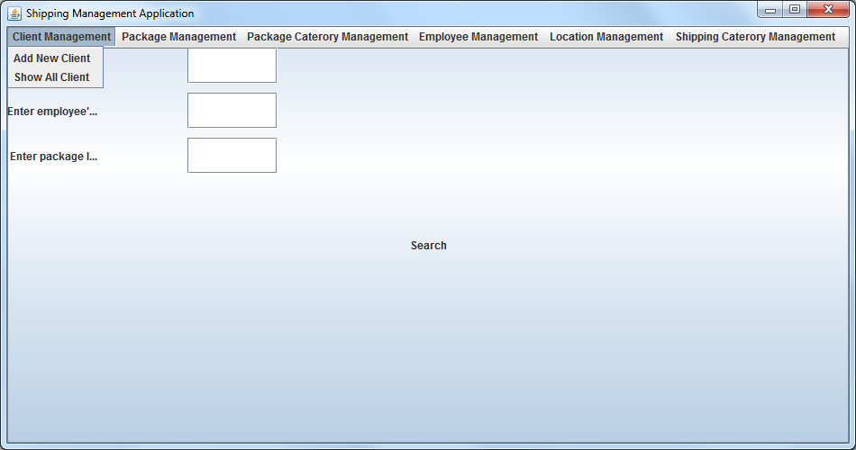

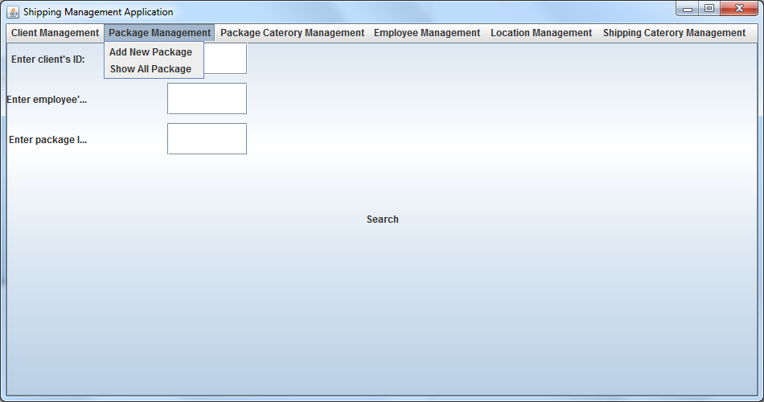

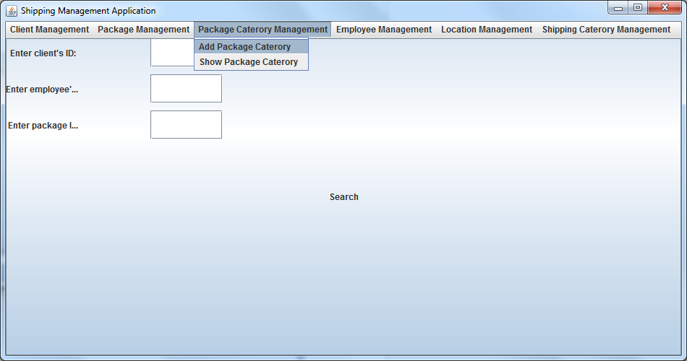

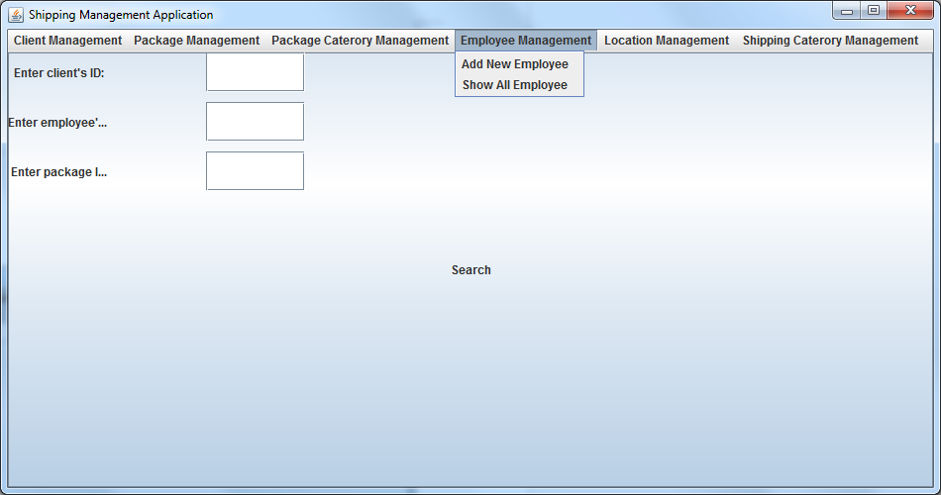

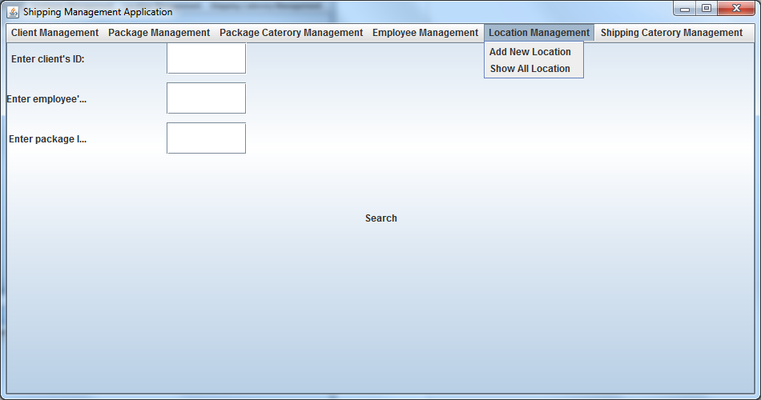

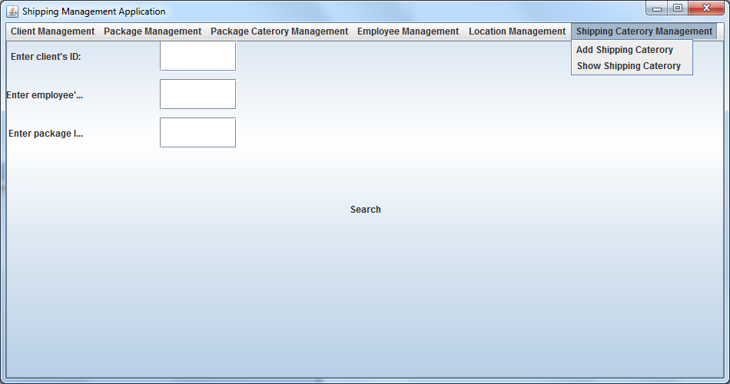

Linan was working on back end (database) table create and record insertion.

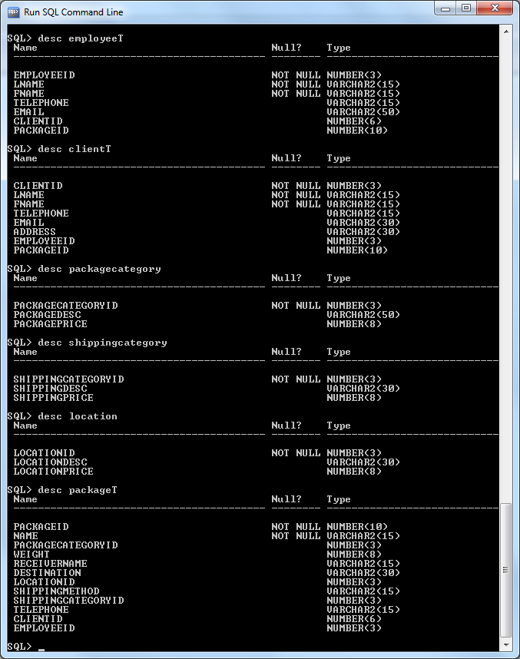

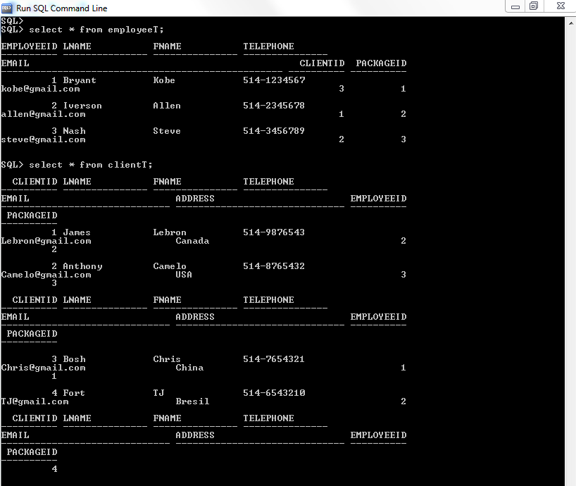

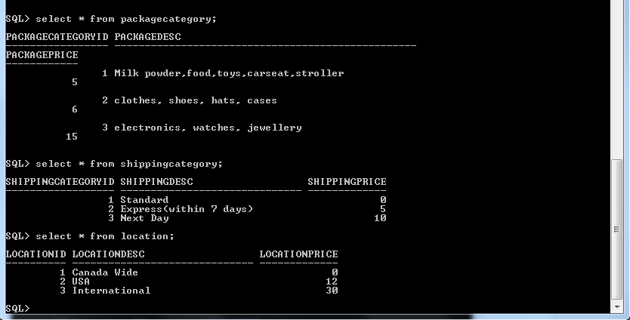

Next Week: processing the SDLC documents and try to connect the front end to database.